Article Title; Times New Roman; Size-16; Line Spacing: Fixed-20pt; Paragraph Spacing: Above Paragraph-10pt, Below Paragraph-10pt. Maximum of 20 words with the first letter capitalized.

Author¹, Author², Author¹ & Author¹

¹ Microbiology Laboratory, Paulista State University, Marilia, Brazil

² Soil Laboratory, Paulista State University, Marilia, Brazil

Correspondence: Author's Name, Microbiology Laboratory, Paulista State University, Marilia, Brazil. E-mail: author1@gmail.com

Received: January xx, 2025 DOI: 10.14295/bjs.v4i1.xxx
Accepted: February 03, 2025 URL: https://doi.org/10.14295/bjs.v4i1.xxx

Abstract
Abstract text. Maximum 400 words.
Keywords: 3 to 5 words, separated by commas.
Título do Artigo; Times New Roman; Tamanho-14; Espaçamento de Linha: Fixo-20pt; Espaçamento de Paragráfo: Paragráfo Acima-10pt, Parágrafo Abaixo-10pt. Máximo de 20 palavras com a primeira letra maiúscula.

Resumo
Abstract in Portuguese. Máximo de 400 palavras.
Palavras-chave: 3 a 5 palavras separadas por vírgula.

1. Introduction
Acceptable citation models are: according to Menezes et al. (2020) or according to the data (Menezes et al., 2020).

Ex:
One author: Menezes (2020) or (Menezes, 2020);
Two authors: Menezes & Ventura (2020) or (Menezes; Ventura, 2020)
Three or more authors: Menezes et al. (2020) or (Menezes et al., 2020)

2. Materials and Methods (They should be separated by subtopics and in chronological order)

2.1 General rules

The materials, equipment, and methodologies used to develop the study must be systematically described. These aspects must be presented in such a way that other researchers who consult the article can reproduce it based solely on what was described in the article.

2.2 Figures and Tables

The Figures should be in Windows-compatible programs, such as Excel, and image format: figures (GIF, JPEG, or TIFF) and photos (JPEG) with 300 dpi resolution. Tables and Figures should be inserted in the text and not at the end of the paper. The calls of the tables and figures in the text begin with capital letters (examples: Table 1, Table 2, Figure 1, Figure 2. etc). The title of the table should be inserted before the Table, to facilitate the insertion of text in the Table footer. The title of the Figure should be inserted after the Figure. Figures and Tables must be saved in editable Word, Excel, or CorelDraw programs for possible correction.

Example Figure:

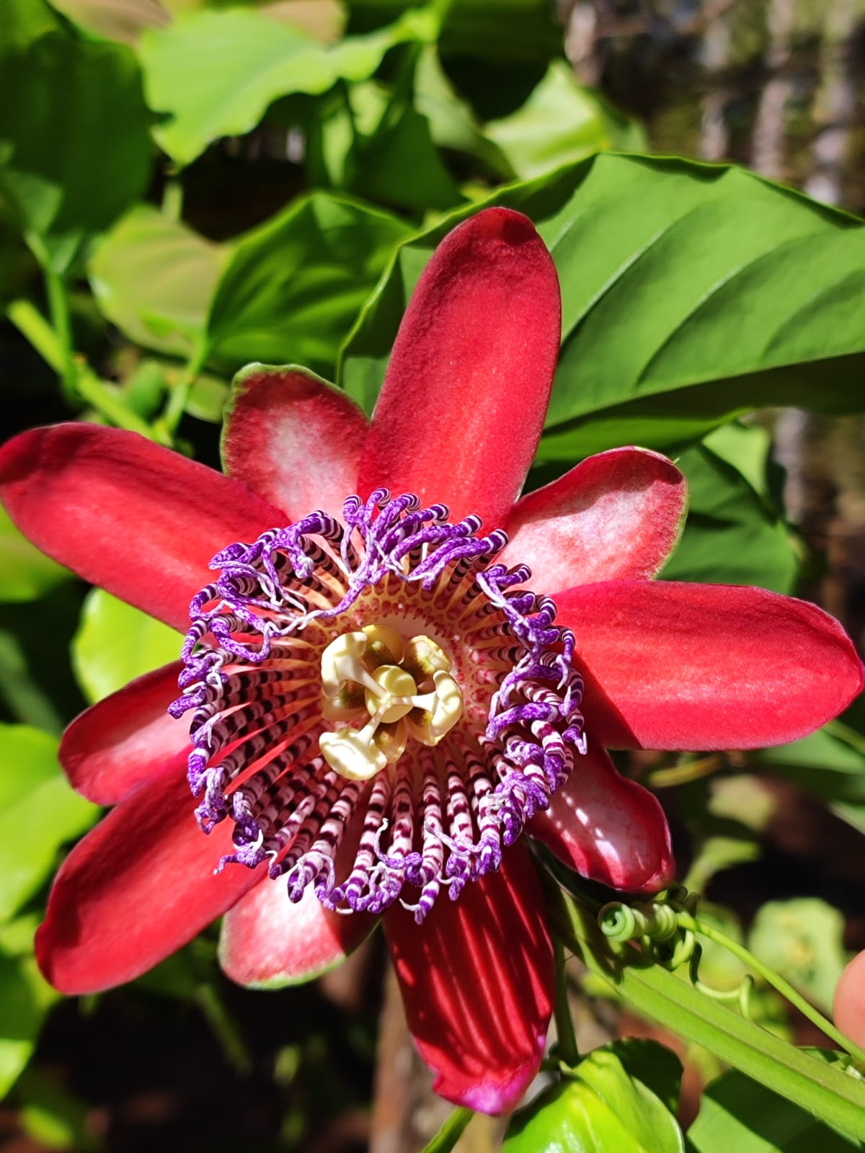

Figure 1. Passiflora incarnata flower. Source: Authors, 2024.

Example Table:

Table 1. Phytochemical composition of Anita muscaria extract.
Chemical profile | Results 1 | Results 2
Tannins | 12.56 ± 0.12b | 23.90 ± 0.11a
Flavonoids | 15.20 ± 0.11b | 41.56 ± 0.12a
Phenols | 50.05 ± 0.21b | 90.56 ± 0.12a
Coumarins | 65.21 ± 1.90a | 30.56 ± 0.12b
Alkaloids | 34.12 ± 1.15a | 34.56 ± 1.12a

Note: Average values ​​from triplicate. Averages followed by the same letter in the row do not differ significantly according to the Tukey test at 5%. Source: Authors, 2024.

2.3 Equations

Equations cited in the text must be indicated and placed in sequence (Equation 1), aligned to the right, and with the equation name in parentheses, as in the example below. Symbols and abbreviations present in the formulas must be identified immediately after the presentation of the formula. Use the Word formula editor.
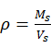 (1)
where: ρ = specific mass of a sample, in g cm³; Ms = dry mass of a sample, in g; Vs = saturated volume of a sample in, g cm³.

2.4 Graphs
In graphs, variables on the X and Y axes must be capitalized and must be followed by the units in parentheses (X) and (Y) or by example titles below. The points on the curves must be represented by contrasting markers, such as circle, square, triangle, or lozenge (filled or empty). The numbers representing the quantities and their respective marks must be outside the quadrant. The curves must be identified on the graph (in the case of only one “trend line” curve there is no need for identification), avoiding excess information that compromises the understanding of the graph. In the case of bar and column graphs, whenever possible use a gray scale (example: 0, 25, 50, 75, and 100%, for five variables).

Example Graphy:

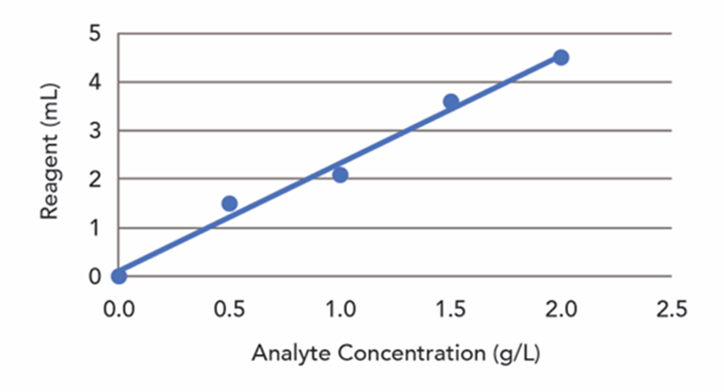

Graph 1. Standard curve of ascorbic acid. Source: Authors, 2024.

2.5 Figures, diagrams, and other non-originals

Non-original figures (authored by the author) must include, after the title, the source from which they were extracted; the sources must be referenced. Credit to the author of photographs is mandatory, as is credit to the author of drawings and graphics that required creative action in their creation. The image source must be cited in the References topic.

Example:
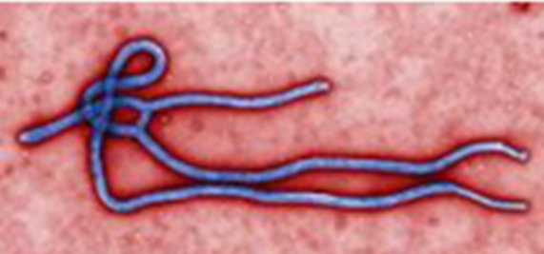

Figure 1. Electron micrography of an Ebola virus. Source: Thippeswamy, (2015).

3. Results (separate from the discussion – this formatting will be adopted to serve international indexing databases)

3.1 General rules

The results must be presented in the text itself or with the help of Graphs, Figures and/or Tables. NOTE: The data in Tables and Figures must not be repeated in the text.

4. Discussion
The discussion of data should be based on technical-scientific articles published preferably in high-impact national and/or international journals. Citations of theses, dissertations, and papers published in conferences should be avoided whenever possible. The results obtained in the articles and technical notes must necessarily present associated statistical analyses.

5. Conclusions
The conclusion should not contain a citation.

6. Acknowledgments (Optional)

7. Authors’ Contributions
Describe each author's contributions to the study.

8. Conflicts of Interest
Yes or No conflicts of interest.

9. Ethics Approval
Yes or Not applicable. OBS: Works involving humans (men, women, children, the elderly, and people with special needs) must be reviewed by the Ethics Committee. Works in this sense that do not present the process number will be returned to the authors for correction. The standards also apply to animal use.

10. References
Conditions
The references used as a basis for the preparation and discussion of the papers must have the following characteristics:
• At least 65% must be articles published in the last 10 years;
• At least 60% must be articles in journals indexed in the Web of Science, Scopus, or Scielo databases;
• The maximum number of citations allowed for each paper will be 15 for technical notes, 35 for scientific articles, and 55 for literature reviews.
Characteristics that should be avoided
Avoid the following cases:
• Self-citation of authors (authors of the work should avoid citing their works as sources) except when strictly necessary, not exceeding 10% of the total references;
• Citations of Theses and Dissertations should be replaced, whenever possible, by articles originating from these works;
• Citations of software should be avoided whenever possible. If citation is essential, authors must present the institutional and/or individual license that allows the use of the software;
• Citations of books or book chapters should be used only when their use is essential and indispensable for the work. Otherwise, they should give way to articles published in journals.

Reference Models
Formatting rules: Indent: 0 cm left and right; Special: Offset, 2 ch; Spacing 0 pt before and 10 pt after; Line spacing: Exactly 12 pt.

Altieri, M., & Nicholls, C. (2018). Biodiversity and pest management in agroecosystems. Boca Raton: CRC Press.
Ventura, M. V. A. & Costa, E. M. Reguladores vegetais na cultura da soja. In: Dias, J. P. T. Usos e aplicações de reguladores vegetais. Belo Horizonte: EdUEMG.
Brasil (2020). Instrução Normativa nº 61, de 8 de julho de 2020 do Ministério da Agricultura, Pecuária e Abastecimento/Secretaria de Defesa Agropecuária. Available in: <https://www.in.gov.br/en/web/dou/-/instrucao-normativa-n-61-de-8-de-julho-de-2020-266802148>. Access on: July 20, 2021.

FORMATTING THE REFERENCES
Journal article:
Name of all authors. (Year of Publication). Title of the article. Journal title in italics, volume (edition): initial and final page. doi: (insert when there is)

Example
Ventura, M. V. A., Chagas, J. F. R., & dos Santos, G. R. (2018). Effect of fungicides in common cashew chestnuts and cashew in Cerrado in the South of Tocantins, Brazil. Academia Journal of Agricultural Research, 6(4), 100-105. https://www.doi.org/10.15413/ajar.2018.0103

Book:
Name of all authors. (Year of Publication). Book's title in italics. Place of publication: Publisher.

Example:
Altieri, M., & Nicholls, C. (2018). Biodiversity and pest management in agroecosystems. Boca Raton: CRC Press.

Book Chapter:
Name of all authors. (Year of Publication). Book chapter title in italics. In: Name of all organizers. Book's title in italics. Place of publication: Publisher.

Example:
Ventura, M. V. A. & Costa, E. M. Reguladores vegetais na cultura da soja. In: Dias, J. P. T. Usos e aplicações de reguladores vegetais. Belo Horizonte: EdUEMG.

Web page:
Name of all authors. (Year of Publication). Title in italics. Available in: <link>. Access on: <date>

Example:
Brasil (2020). Instrução Normativa nº 61, de 8 de julho de 2020 do Ministério da Agricultura, Pecuária e Abastecimento/Secretaria de Defesa Agropecuária. Available in: <https://www.in.gov.br/en/web/dou/-/instrucao-normativa-n-61-de-8-de-julho-de-2020-266802148>. Access on: July 20, 2021.

Funding
Yes or Not applicable. Whenever public or private funding is involved, its source must be presented.

Institutional Review Board Statement
Yes or Not applicable.

Informed Consent Statement
Yes or Not applicable.

Copyrights
Copyright for this article is retained by the author(s), with first publication rights granted to the journal.
This is an open-access article distributed under the terms and conditions of the Creative Commons Attribution license (http://creativecommons.org/licenses/by/4.0/).

